1.
Preheat the oven to 220°C/ 200°C (fan)/ 425°F/ Gas 7
Boil a kettle
Slice the whole butternut squash in half, then scoop out and discard the seeds
Tip: For easier cutting, use a bread knife (oiling the knife helps too!)
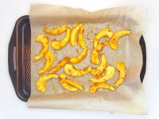
2.
Slice each squash half into 1cm wedges and add them to a bowl with the Thai red curry paste, a pinch of salt and 1 tbsp [2 tbsp] vegetable oil and mix well
Put the marinated squash wedges onto a baking tray lined with non-stick baking paper and put the tray in the oven for 20-22 min or until cooked through but with a slight bite
Remove from the oven and set aside
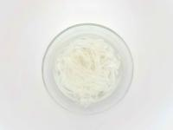
3.
Place the rice noodles into a bowl and cover with boiled water
Set aside for 15 min to soften
Once softened, drain the rice noodles and keep to one side
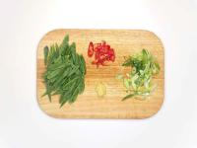
4.
Peel and finely chop (or grate) the garlic
Slice the mangetout in half diagonally
Slice the spring onion[s] and red chilli[es] finely
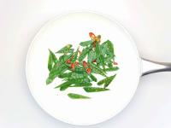
5.
Heat a large, wide-based pan (preferably non-stick) with a drizzle of vegetable oil over a medium-low heat
Add the chopped garlic and half of the sliced red chilli (can't handle the heat? Go easy!) and cook for 3-4 min until starting to caramelise
Once caramelised, add the mangetout and cook for 3-4 min or until starting to soften
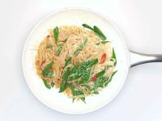
6.
Meanwhile, combine the soy sauce, Sriracha, tamarind paste, 1 tbsp [2 tbsp] sugar and the juice of 1/2 [1] lime – this is your pad Thai sauce
Add the drained rice noodles and the pad Thai sauce to the pan, stirring until everything is evenly coated in the sauce
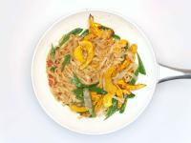
7.
Remove the squash wedges from the baking tray and add to the pan, stir to combine for 1 min then turn off the heat and cover - this is your spicy squash pad Thai
Meanwhile, crush the peanuts in the bag with a rolling pin
Slice the remaining lime into wedges
Serve the spicy squash pad Thai with the crispy onions, sliced spring onion, remaining sliced chilli (not a fan of spice? Just add a little!) and crushed peanuts on top
Garnish with a lime wedge
Enjoy!

